https://medium.com/@elifakin2004/ocean-tales-c3ac2aad8fed

Ocean Tales
One thing about solo travelling that I can never give up is that you get to meet people from all around the world. Each conversation opens up a window for you to peer into yet another culture so distinct from yours, yet similar in some way. The ocean, or the sea, is one of those points of unity.
The dark, unknown waters of the Oceans have always been a source of excitement for humankind. The mystery of what swims underneath the waves has been a creative force, encouraging the mind to go about in all directions, creating stories and myths and culture.
So here are some tales that I’ve gathered from people all over the world :)
Whale Island
Out in the Pacific ocean, a little off the coast of Peru, there is an island called the “Whale Island”. Better known as the Pachacamac Island, the island is best seen from the beach of the town of Lurin, and is accompanied by a smaller island, resembling a dolphin’s dorsal fin.
Back in the days of Incan rule, Mama Aglla’s sanctuary was a harem of the most beautiful women. These women were not concubines, but rather sacred, selected throughout the empire to serve the emperor and bring luck through their beauty. The most beautiful of them would be married to the emperor.
In Cuzco was a girl as bright as the sun and as pretty as Pacha Mama, the Earth Mother. Just by her way of being, she stole the Emperor’s heart and was to be taken to the harem to prepare for their marriage. Yet, just before being taken away, she fell in love with a lieutenant. He was sweet and charming, and loved her in a way she could never have imagined. But who was a lieutenant compared to the emperor? Their love story was one that was doomed — one that had no start, let alone an ending. She had no choice but to join the other maidens of the harem.
She soon fell into a deep state of agony, imagining how wonderful it could’ve been to be with the love of her life, and how awful it would be with a man she didn’t even know. She turned and turned in her bed. She cried and cursed at her beauty.
The lieutenant hated to see her in this state. She, who shone and radiated the warmest of energies, deserved the universe. And so he set foot on a journey. A journey with no return. He prayed and prayed to meet Viracocha, the God who created everything: the world, the sun, the moon, the stars, and humanity. Day after day he prayed, until one day Viracocha responded to his prayers. “What is it that you want, mi hijo?” he asked. All the lieutenant wanted was to forever be with his lover. “What is it that you want, mi hija?” he asked the girl. All the girl wanted was to forever be with her lover. “Alright, then”, he said, and told them what to do.
On the next full moon, Viracocha sang lullabies into the ears of the Incan guards. As they fell into the deepest of sleeps, the lieutenant sneaked into the harem and took his lover by the hand, yet he wasn’t careful enough. The maidens saw them and sent word to the emperor. There was no way out. Seeing the turn of events, Viracocha asked, “Do you still want to forever be side by side?”. “Yes!” both answered from the deepest pool of their heart. “Alright, then”, Viracocha said, before transforming the girl into the whale island and the lieutenant into the dolphin’s fin. “May the waves of the Pacific keep you together forever”.

Selkies
The Orkney Islands are 70 islands around 16 km off the north coast of Scotland. With only 20 of them inhabited, the islands share a number of legends, some influenced by Nordic mythology. One is the legend of the Selkies, the seal people.
It is said in Orkney lore, that Selkies live as seals during the day and come up ashore during the night. Stripping from their seal skin, they dance the night away in a human’s disguise. Their beauty is so captivating that fishermen often fall deeply in love, enchanted by the Selkie’s false skin.
On one nightfall, a fisherman got carried away and kept fishing until dawn. Realising the night had started swallowing the sky, he hurriedly rowed back ashore. The night never brought good news. As he pulled his boat onto the sandy beach and gathered all his fishing gear to head home, a faint sound of music clung to his ears. It was coming from the next bay. Scared, yet curious as much, he tiptoed his way to see what was going on. Was it a party which he wasn’t invited to? Was there a celebration? Or was the sly night making him imagine things?
He sat himself on the back of a rock and peered from behind. The dark sky was brightened by the stars, whose lights elegantly caressed the beautiful skins of dancing women. Surely he was hallucinating. Yet, no matter how many times he blinked or rubbed his eyes, the beautiful women did not disappear. It was then that he came to realise that the women were Selkies — they were not women at all. Oh how pretty they all were, dancing to the sound of the waves and pebbles and their own enchanting voice. But one particularly caught his eye. With reason blinded by illusion and desire, he spotted where her skin lay, and stole it away. The Selkie, was now bound to the land.
It is when the night comes to an end that the Selkie must return home. Yet with her skin stolen, she is cast away on shore, watching her friends dive back into the arms of their ocean home. The Selkie searched and searched the land in vain, her true skin, nowhere in sight. The fisherman, acting as though innocent, approached the weeping girl and asked her what was wrong. He offered her clothes and warmth and a bed to sleep on. What a kind man this is, thought the Selkie.
Days passed, and the skin was not found. She understood that land was to be her new land. The fisherman took the weeping Selkie by the hand and made her his wife. They had a family and kids, yet the Selkie never quite warmed up to life on two feet. Her time was spent staring out at the vast ocean, listening to the howls of her family at night, calling her back home.
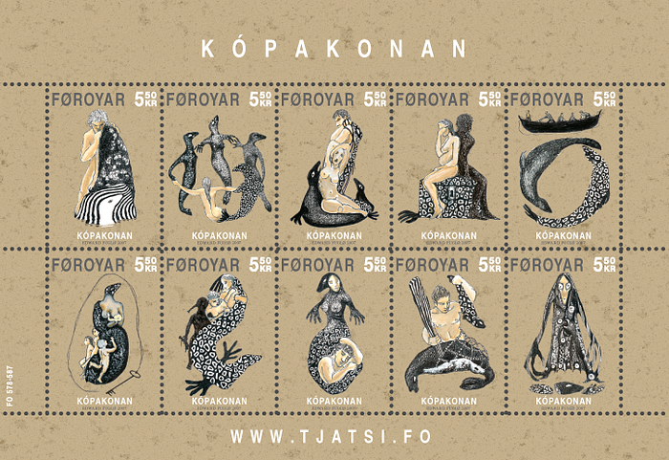
‘Seal Woman’ Stamps
A brief note on conservation: Seals and sea lions are intentionally killed by some fishermen around the world, with claims that they are eating too much fish, leaving none for humans. These animals, having inhabited the same coasts as fishermen for centuries, have been doing their thing since the beginning of their time. The only thing that has changed since then is the population of Homo sapiens upon Earth, followed by an increased demand for food, hence increased industrialisation, and hence increased fishing activity. This increase in fishing activity and the intentional killing of seals and sea lions has severely declined their populations. Therefore, the remaining animals are searching for food that is just enough to feed their young, all the while, this food is taken away by the countless fishermen roaming about the sea. And the blame, is unjustly dropped on their heads, which are cut open, and spread out on shores in mass strandings. It’s important to stay aware.
Urashima Taro
Once upon a time, there lived a young fisherman named Urashima Taro. One day, Taro came upon some children who were torturing a sea turtle on the beach. Feeling pity for the turtle, Taro told the children to let it go, but they would not stop. Taro finally saved the turtle and let it return to the sea.
Several days later, the turtle appeared before Taro once again and called to him. “Thank you for rescuing me the other day. You saved my life.” The turtle then extended an invitation, “In return, please allow me to show you Ryugu-jo, the palace of the Dragon King. Come, ride on my back.” Taro thought he would indeed like to see Ryugu-jo, so he seated himself on the turtle’s back. Together, they dove deep into the ocean.
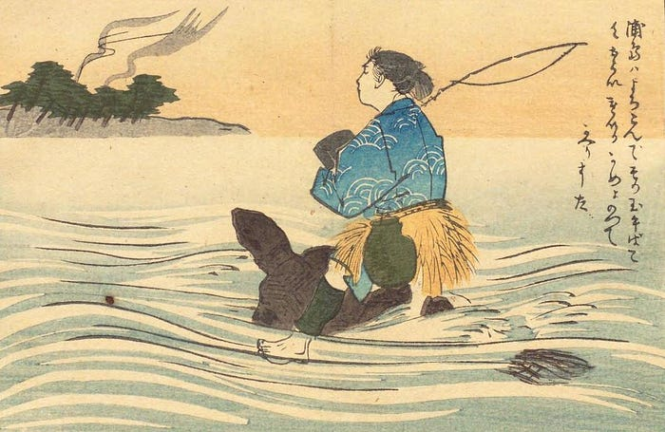
Image link
In what seemed like a brief moment, Taro and the turtle had arrived at the magnificent gates of Ryugu-jo. At the palace, the princess Otohime gave Taro a warm welcome. Taro watched the sea bream and flounders dance, took part in many feasts, and had a wonderful time.
After a few days of parties and feast and laughter, Taro grew homesick for his village and his mother. He told Otohime that he wished to go back home. The princess was greatly distressed at his words, but accepted his desire to leave. She gave him a special box called a tamatebako as a parting gift— with strict instructions to never open it.
Taro rode a turtle back to shore. When he arrived, however, the beach seemed completely different. Taro’s home was gone — and so was his mother. Everyone that Taro knew was gone. When he asked the people nearby if they knew an Urashima Taro, they replied that they had indeed heard stories about someone by that name, who long, long ago sank beneath the ocean waves and disappeared. It was then that Taro learned that three hundred years had passed since he had gone to Ryugu-jo.
Thinking that all might return to the way it had been if he opened the tamatebako, Taro lifted the lid despite the princess’ warning. When he did so, however, a puff of white smoke came out of the box. The white smoke engulfed Taro and left him an old man, with white hair and beard. The three hundred years in which his youth was preserved seemed to be catching up with him. And in seconds, all that was left of him was a pile of bones, and a legend that lingered in the streets of the village.
A brief note on conservation: Sea turtles, with their graceful ways of swimming and seemingly tranquil nature, are animals of great importance for our seas and oceans. They maintain healthy seagrass beds, protect coral reefs by controlling sponge populations, and help balance food webs by eating jellyfish. Along with this, their lifespans are estimated to be 50 to 100 years, which might actually be even more. Yet, they are not quite adapted to the sudden changes brought about by human advancements. Little hatchlings that hatch out of their eggs at night confuse building lights with the shimmer of the ocean and head towards the wrong direction, their death. Plastic bags appear like jellyfish and end up in their stomachs. Oil spills destroy their beloved seagrass, and so on… They protect nature. Let’s return this kindness with kindness.
Natsilane
For the Tlingit people of the Northwest Coast of North America, the sea otter holds an important place. They are symbols of playfulness, hard work, and, most importantly, peace.
Long ago, in a coastal village surrounded by forests and the sea, there lived a young man named Natsilane. He was strong, kind, and skilled at carving wood. His talent and good nature made others jealous — especially his four brothers-in-law, who resented the praise and affection he received from the people.
The wind smelled of salt and cedar that morning when Natsilane set out to sea with his brothers-in-law. The sea was calm, a vast sheet of silver that mirrored the grey sky above. The men paddled quietly.
Behind Natsilene, who held a soft gaze of admiration out on the sea, jealousy was boiling like a dark current. His brothers-in-law watched his back with cold eyes. They resented his skill, his quiet strength, and the way the villagers admired the things he carved — masks that seemed to breathe, totems that seemed alive. When they reached deep water, hands shoved him from the canoe. The sea swallowed his cry.
Cold gripped him instantly. He kicked and thrashed, but the canoe was already a dark shape drifting away. Hours passed. The waves tossed him like driftwood, until finally his hands found rock. He pulled himself onto a small island — barren, windswept, and lonely. That night, as he lay trembling beneath the stars, Natsilane prayed. He called out to the spirits of the sea, to any creature who might hear. And the sea answered.
Just as his strength gave out, a soft shape brushed against him — a sea otter, curious and gentle. It circled him, and others joined to help lift Natsilane to their island home.
The otters wrapped him in kelp and brought him fish to eat. In time, Natsilane grew strong again. To thank them, he carved tools and ornaments from driftwood that washed ashore, and the Otter Chief grew fond of him. “You have repaid our kindness, Natsilane. Now it is time for you to return to your people. But before you go, remember this — the sea will listen to your heart if your heart is true.”
Natsilane built himself a canoe and returned home. The village welcomed him, astonished to see him alive. His brothers-in-law said nothing. But Natsilane carried a quiet fire within him — not hatred, but the need for balance.
He began to carve once more, this time from a great piece of yellow cedar. He shaped it with care: a strong body, sleek fins, and eyes that shone with wisdom. When it was done, he dragged it to the shore and spoke softly to the sea. The waves lapped around the carving’s tail. The wood shook, and with a great splash, the first killer whale was born. It circled his canoe, black and white and alive with spirit.
Natsilane bent close and whispered, “My brothers-in-law betrayed me. Find them and bring them to justice, but harm no one else.” The killer whale disappeared beneath the waves. Days later, the sea swallowed the brothers-in-law’s canoe, and they were never seen again.
“You have done enough,” he said. “From this day forward, protect those who travel upon the sea. You will be the guardian of the ocean, my brother of the deep.”
And so the people say that when you see a sea otter floating on its back or a killer whale gliding through the surf, you see the friends of Natsilane — spirits of kindness, justice, and the unbroken bond between humans and the living sea.
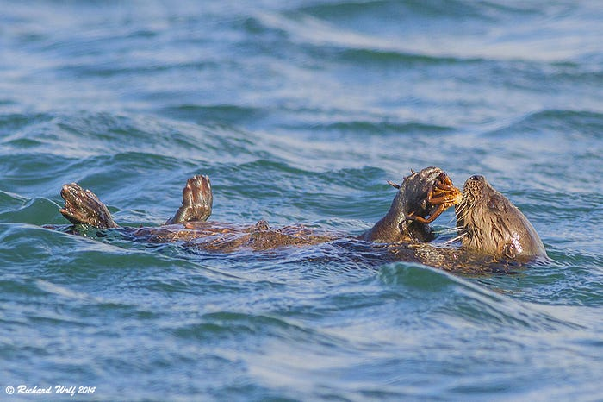
Image Link
A note on conservation: Sea otters (Enhydra lutris) are a species that is recovering from endangerment. While they eat sea urchins to protect kelp forests (a crucial underwater habitat, with the ability to balance the effects of climate change), they have been hunted for their pelage (fur) for countless years, severely declining their populations. Now, a growing feeling of care and love towards these species has significantly improved the species’ well-being. They are often confused with marine otters (Lontra felina), which are still an endangered species with only 3000 individuals left along the Pacific coast of South America, ranging from northern Peru to the southern tip of Chile and Argentina. Although the hunting has decreased, now they face the threat of habitat degradation and pollution. There are only two resident families left on the coast of Perú.
>> Marine otter (Lontra felina) is NOT the same species as sea otter (Enhydra lutris).
Another brief note on conservation: Orcas are animals of great intelligence. This intelligence brings about the need to play, and socialise. They are social animals with social structures. What started as a way to change the negative reputation of killer whales has eventually grown into another way that the rich are getting richer, and the poor are getting poorer. With the exception that this time, the poor are another species in captivity that ends up killed 100% of the time. It is crucial to learn about the ugly truth behind dolphin and whale theme parks.
Although most take quite a dark turn, I find it exciting that a lot of different cultures have a lot of different tales about the ocean. And most of these legends have an undertone of respect for natural life, which I think is one of the best values an Earthling can cultivate.
I hope you enjoyed :)
Elif

Wordlist
sanctuary | Heiligtum
doomed | verdammt
agony | Todesqualen
Lullabies | Schlaflied
swallowing | Schlucken
caressed | Streicheln
pebbles | Kieselstein
enchanting | bezaubernd
distressed | bekümmert
engulfed | jemanden umringen
preserved | konserviert
carving | Schnitzen
cedar | Zedernholz
current | Strömung
resented | sich Akk über jdn/etw ärgern
thrashed | um sich schlagen
windswept | windgepeitschter Strand/windgepeitschte Küste
kelp | Seetang
fond | jdn/etw gerne mögen
astonished | erstaunt
Source: PONS Wörterbuch | Englisch ⇔ Deutsch | 1.8M Übersetzungen

